Name: _______________________

Pythagorean Theorem

1. Draw the following accurately:
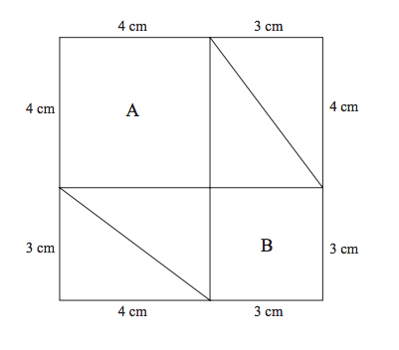

2. Cut out each triangle.

3. Rearrange the triangles into this square, and check that C, which should be empty, is a square.
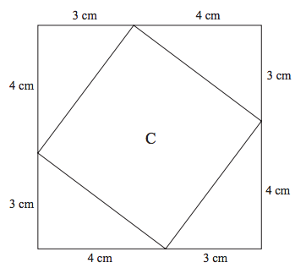
4. What is the total area of A and B?

5. What is the area of C?

6. Why is the area of A + area of B = area of C?

7. What is the length of the Hypotenuse? How did you know?

8. Follow steps 1 – 7 again with this square:
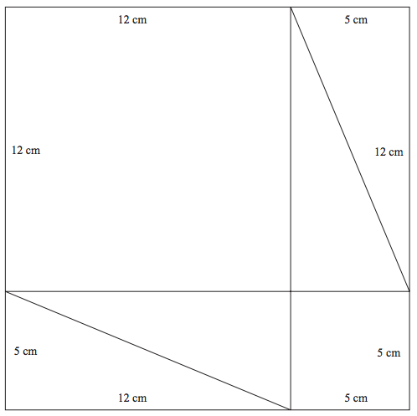

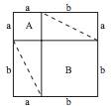
9. Do you notice a pattern?
Hint:

Homework
