Name: _______________________

Pre-Algebra Review

Solve the following:

- 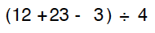

- 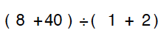

- 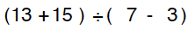

- 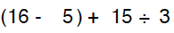

Isolate for x.

- 

 